**EE533 Network Processor Design & Programming**

**Lab #2: Designing of 32-bit ALU using Xilinx ISE 10.1**

Instructor: Prof. Young Cho, PhD

***Name: Archit Sethi***

***University of Southern California***

***Los Angeles, CA 90007***

GITHUB LINK to my REPOSITORY

Aarch0811/EE533/LAB2/

Archit’s GITHUB: [LINK](https://github.com/Aarch0811/EE533/tree/main/LAB2)

1. Designing and Simulating of an 8-bit Synchronous Adder
   1. 1-bit Adder

Implemented the 1-bit Adder using the basic gates from the Xilinx Library ash shown in the schematic.

* + 1. Schematic

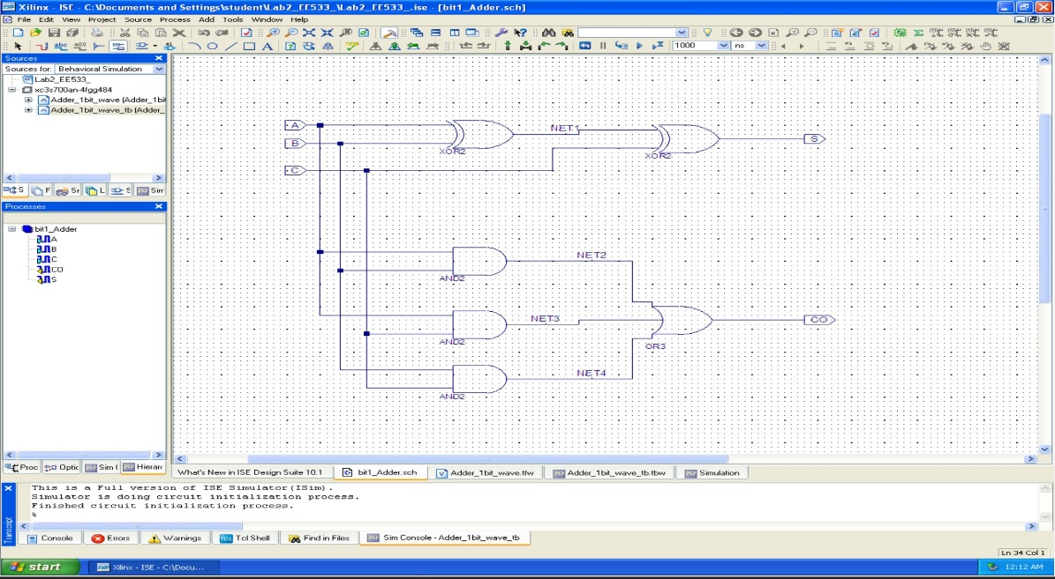

* + 1. Testbench

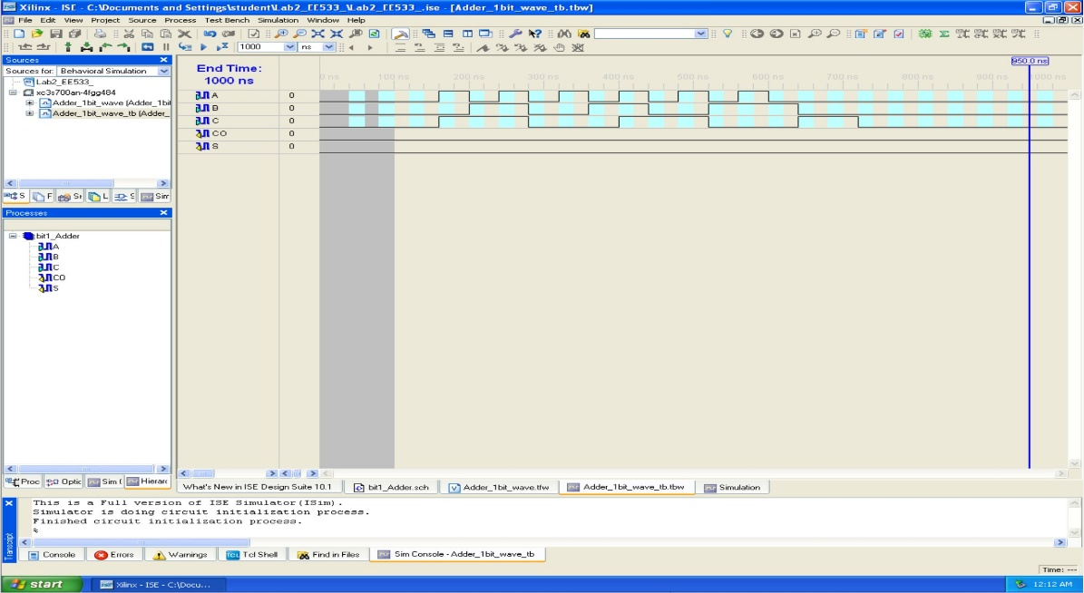

* + 1. Waveform/Simulation

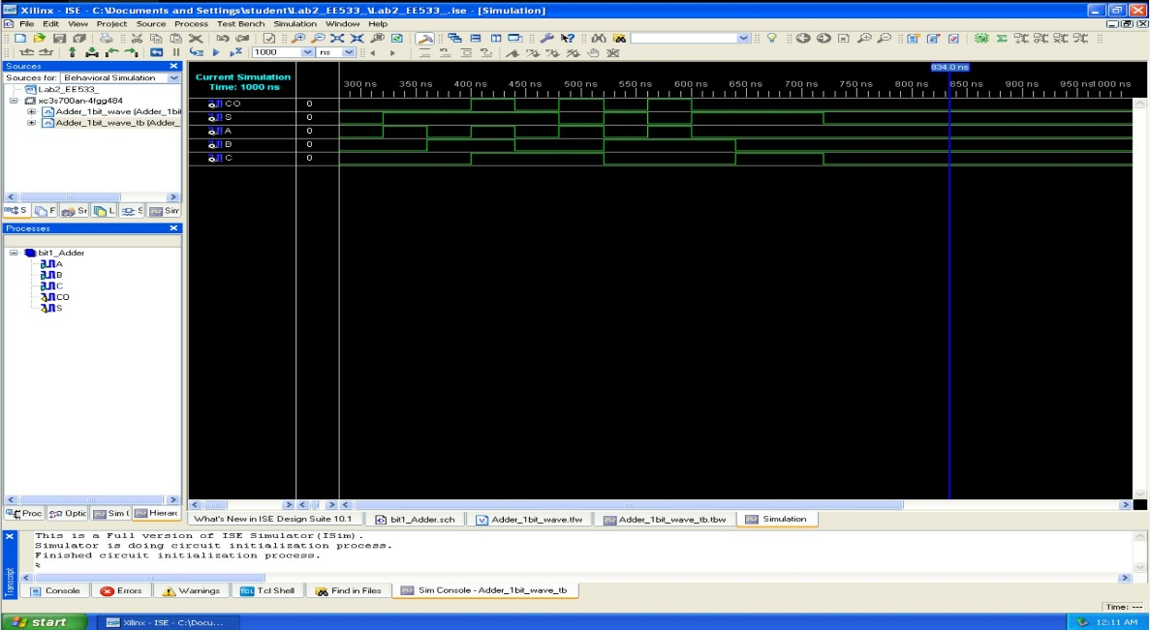

* 1. 8-bit Adder

This adder was designed by instantiating 8 x 1-bit Adders in cascaded fashion and made connections in a 8-bit bus.

* + 1. Schematic

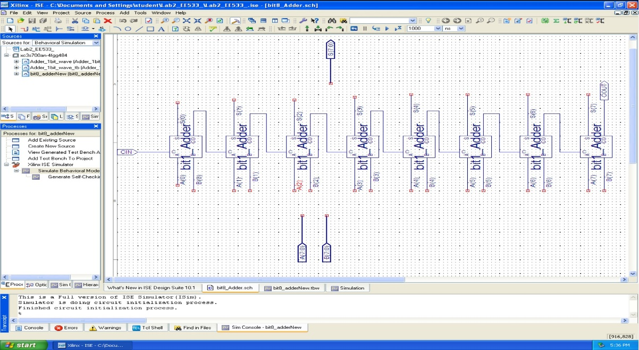

* + 1. Testbench

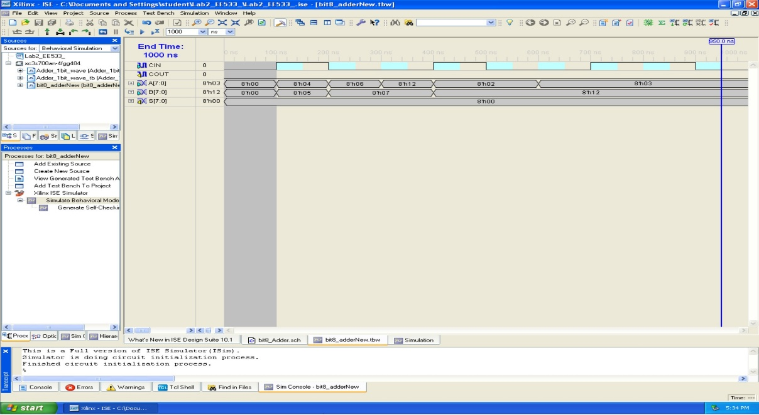

* + 1. Waveform/Simulation

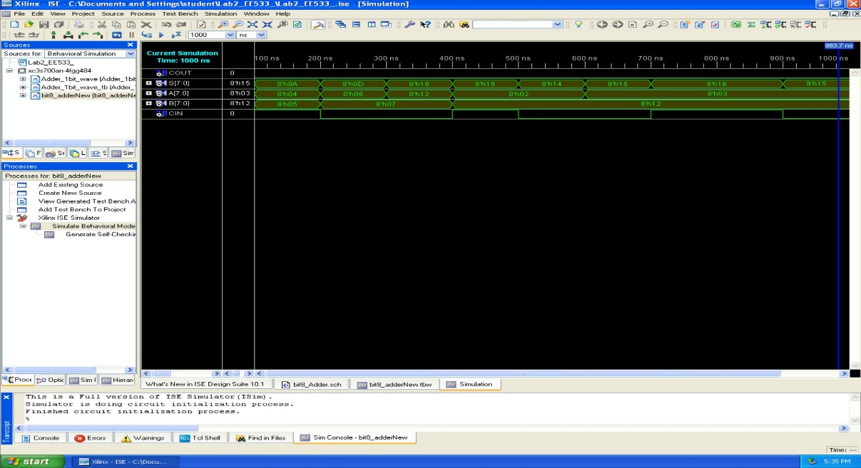

* 1. 8-bit Synchronous Adder

A CLK was added to the 8-bit adder circuit as shown in the schematic below.

* + 1. Schematic

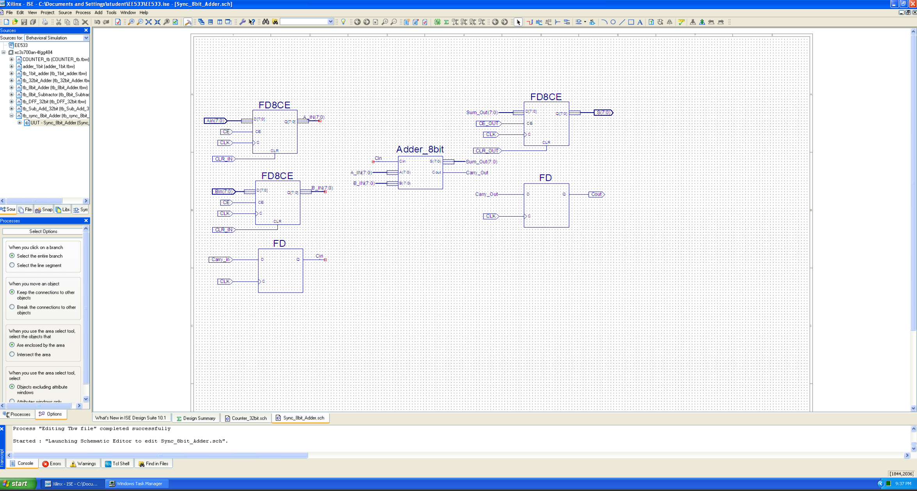

* + 1. Testbench

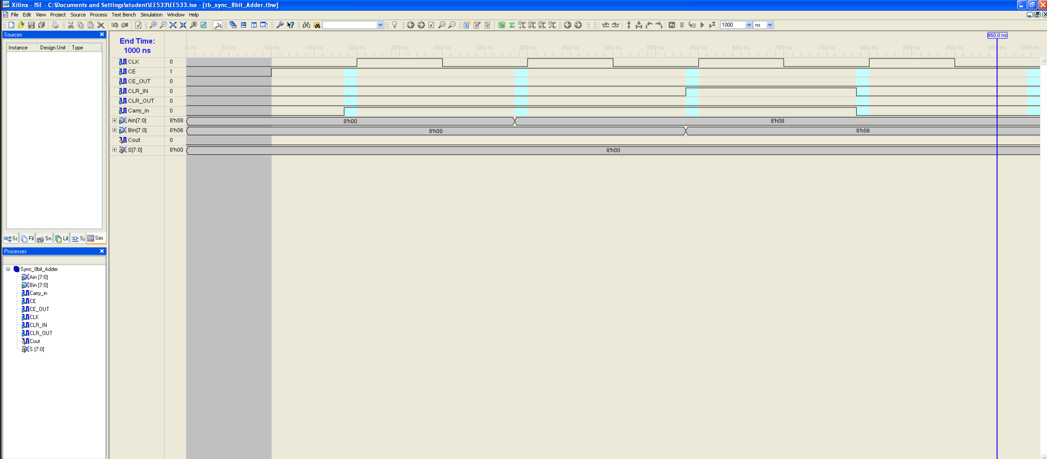

* + 1. Waveform/Simulation

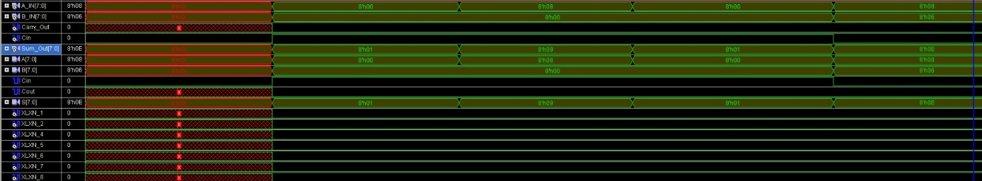

* 1. 32-bit Adder: This adder is created by instantiating 4 x 8-bit Adder symbols in a cascaded fashion and linked with a 32-bit.
     1. Schematic

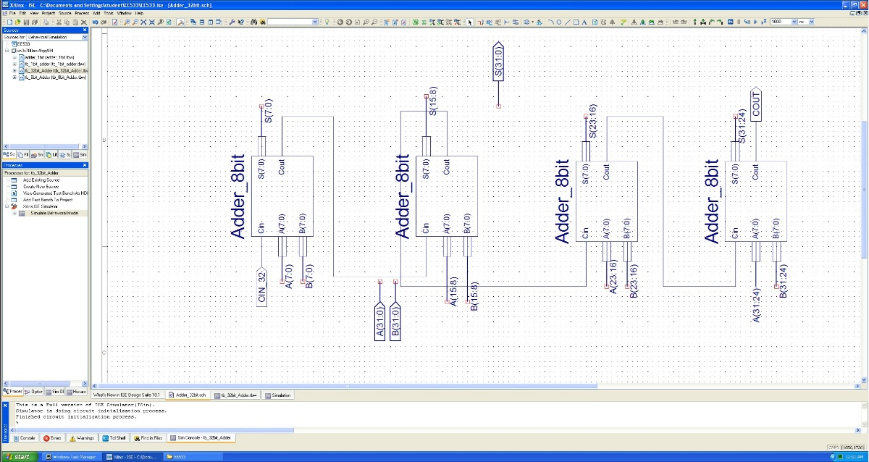

* + 1. Testbench

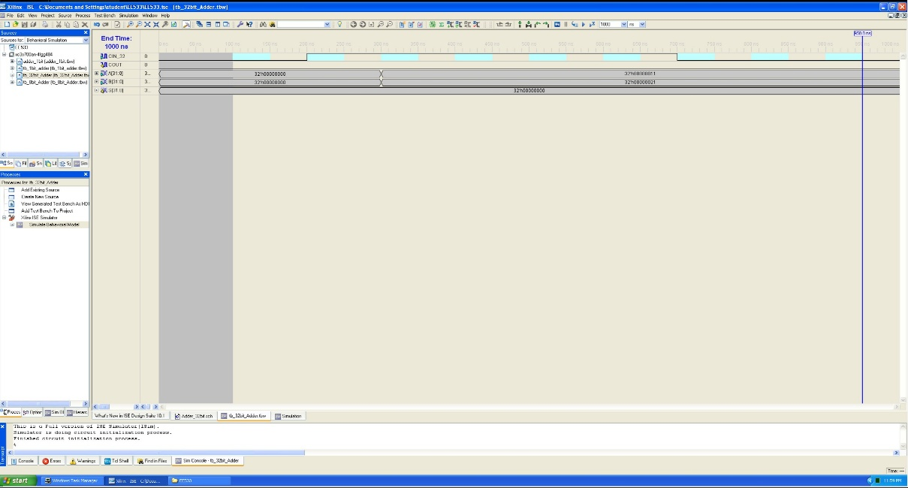

* + 1. Waveform/Simulation

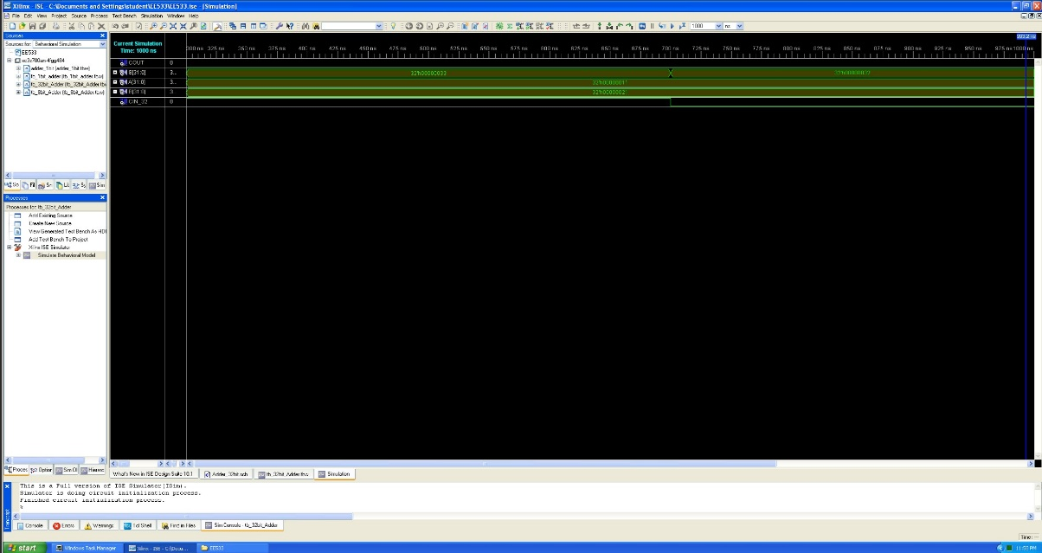

* 1. 32-bit Subtractor
     1. Schematic

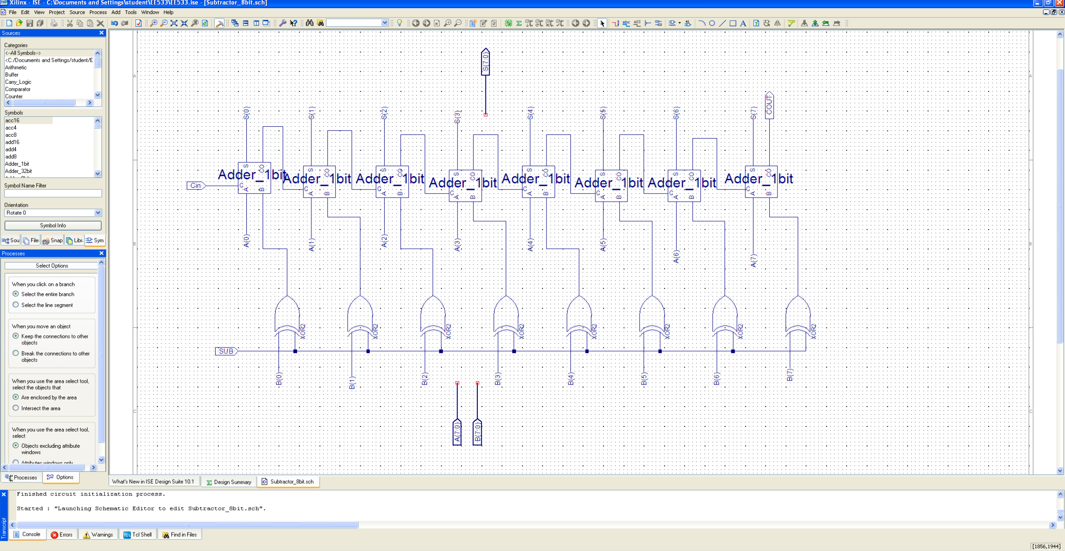

* + 1. Testbench

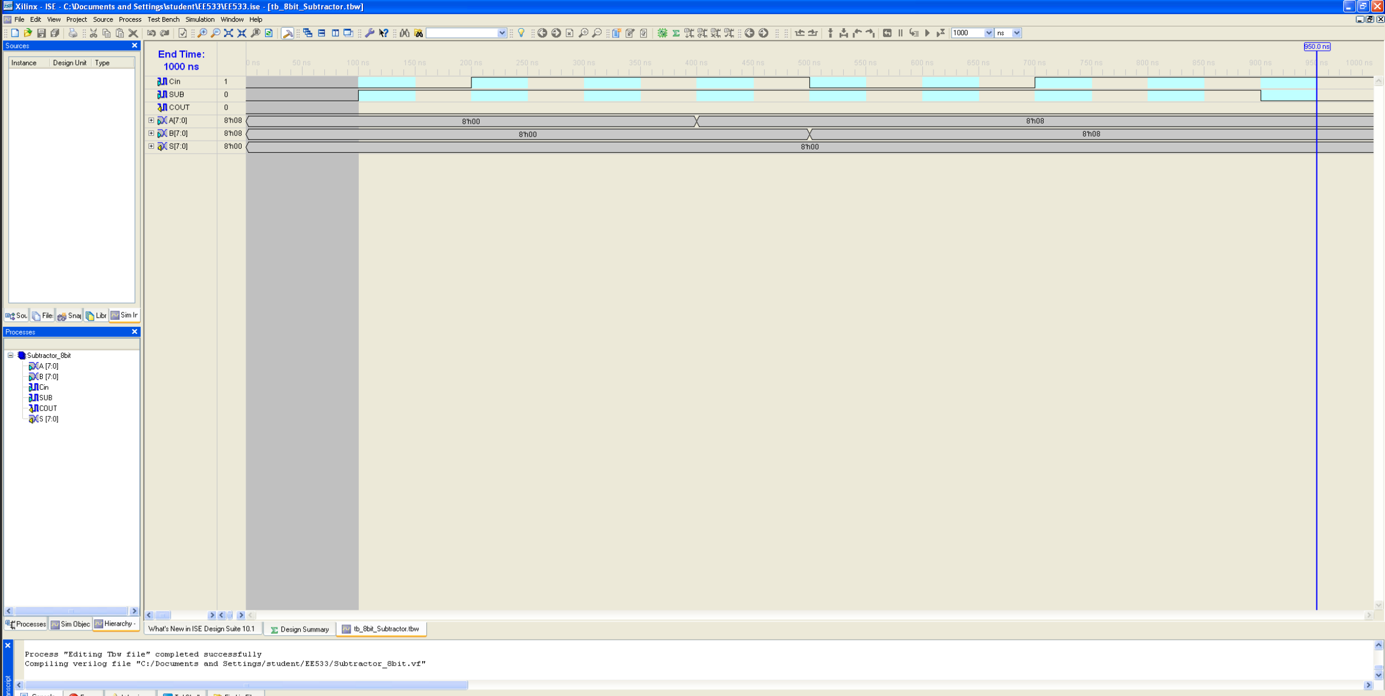

* + 1. Waveform

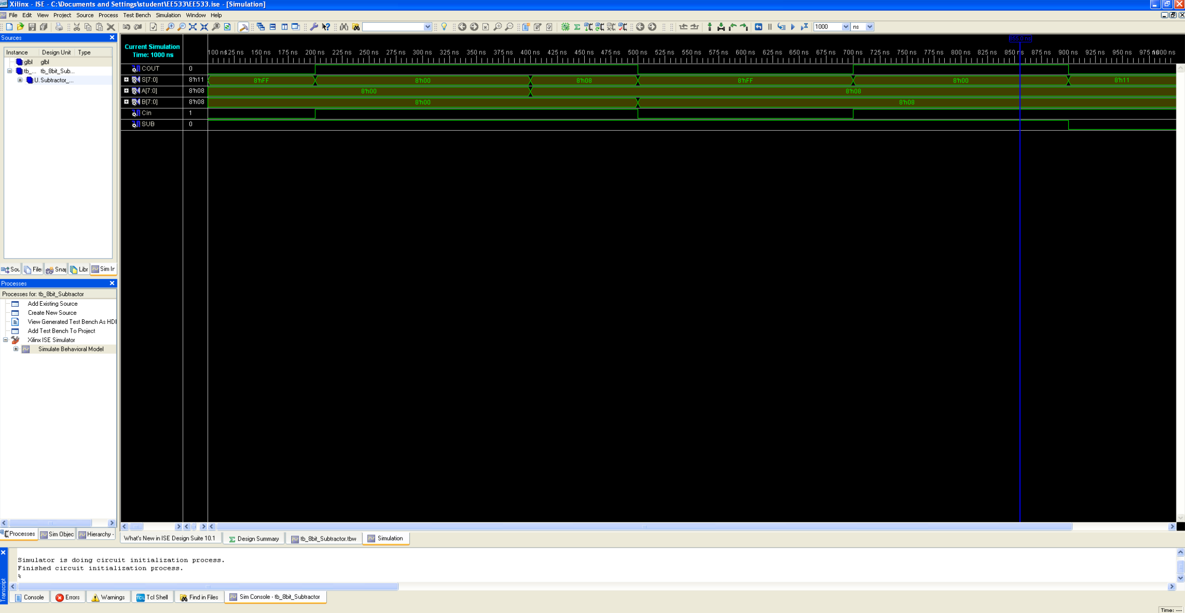

* 1. 32-bit Subtractor/Adder: This is the schematic design for 32-bit adder/subtractor circuit which implements both addition and subtraction using the 1-bit bus line labelled as ‘SUB_ADD’
     1. Schematic

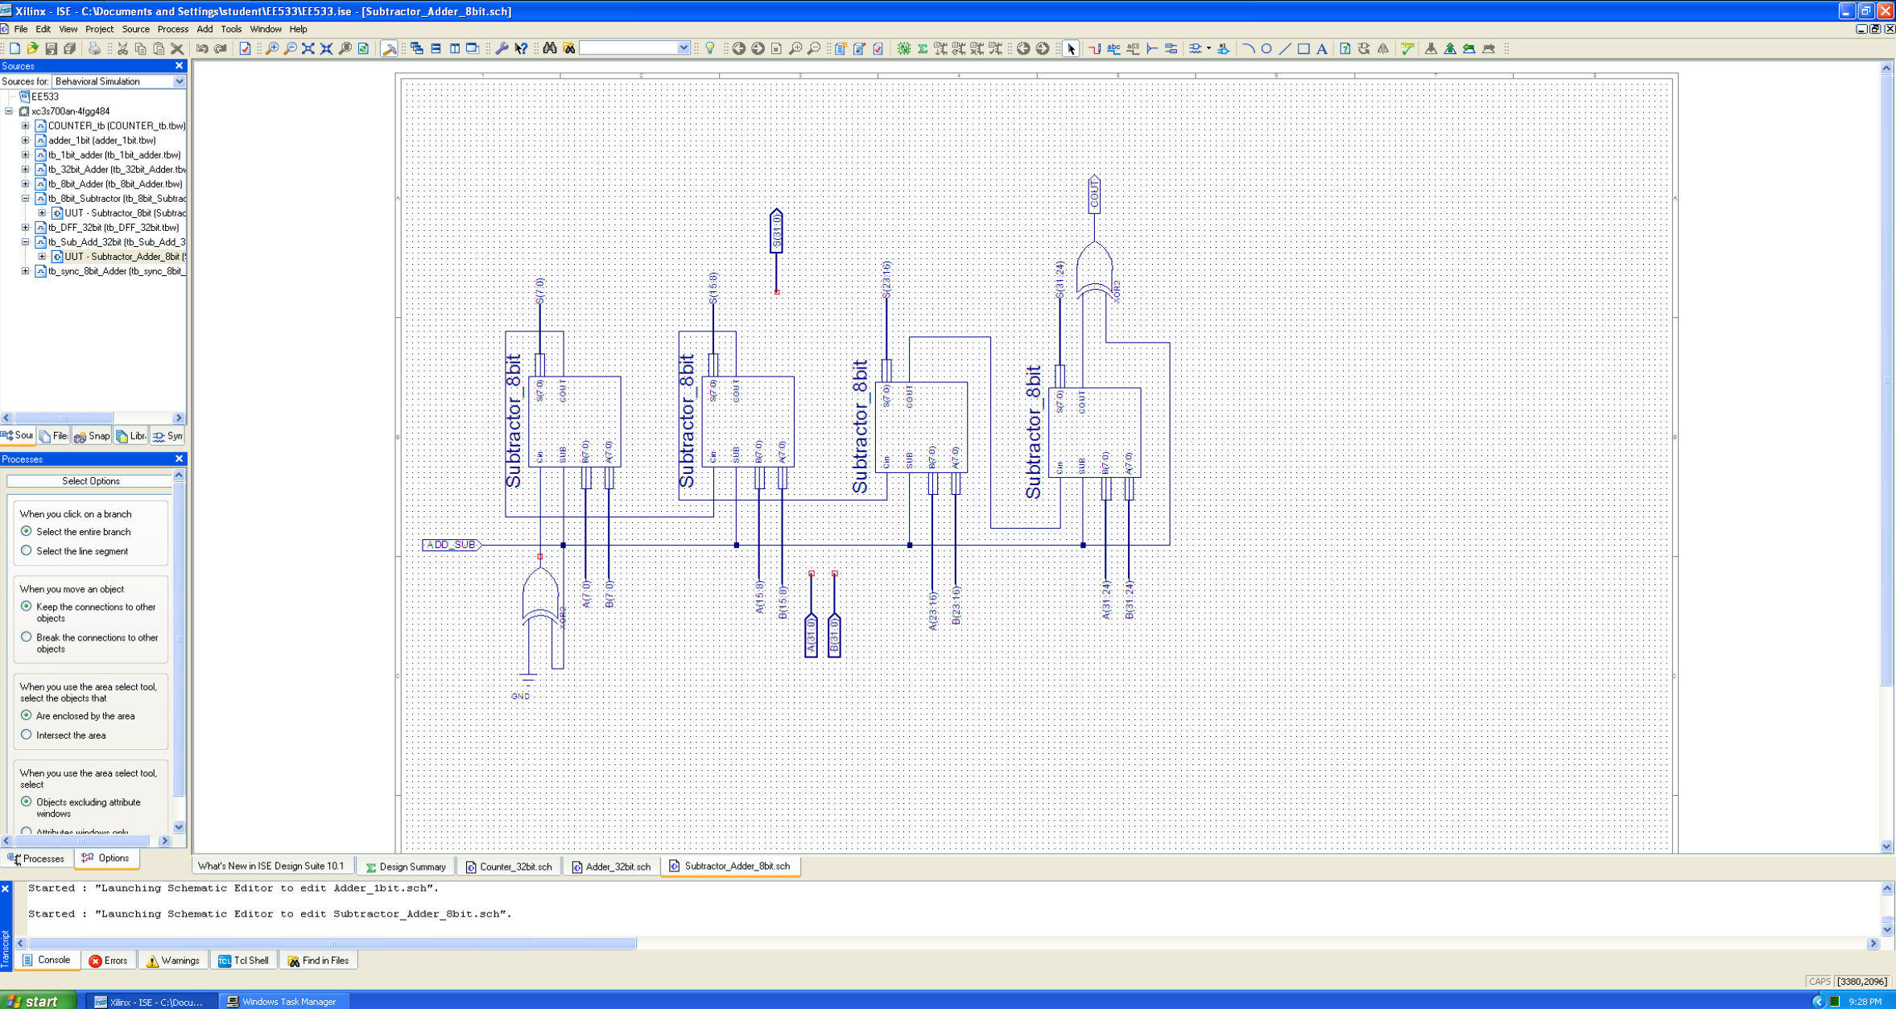

* + 1. Testbench

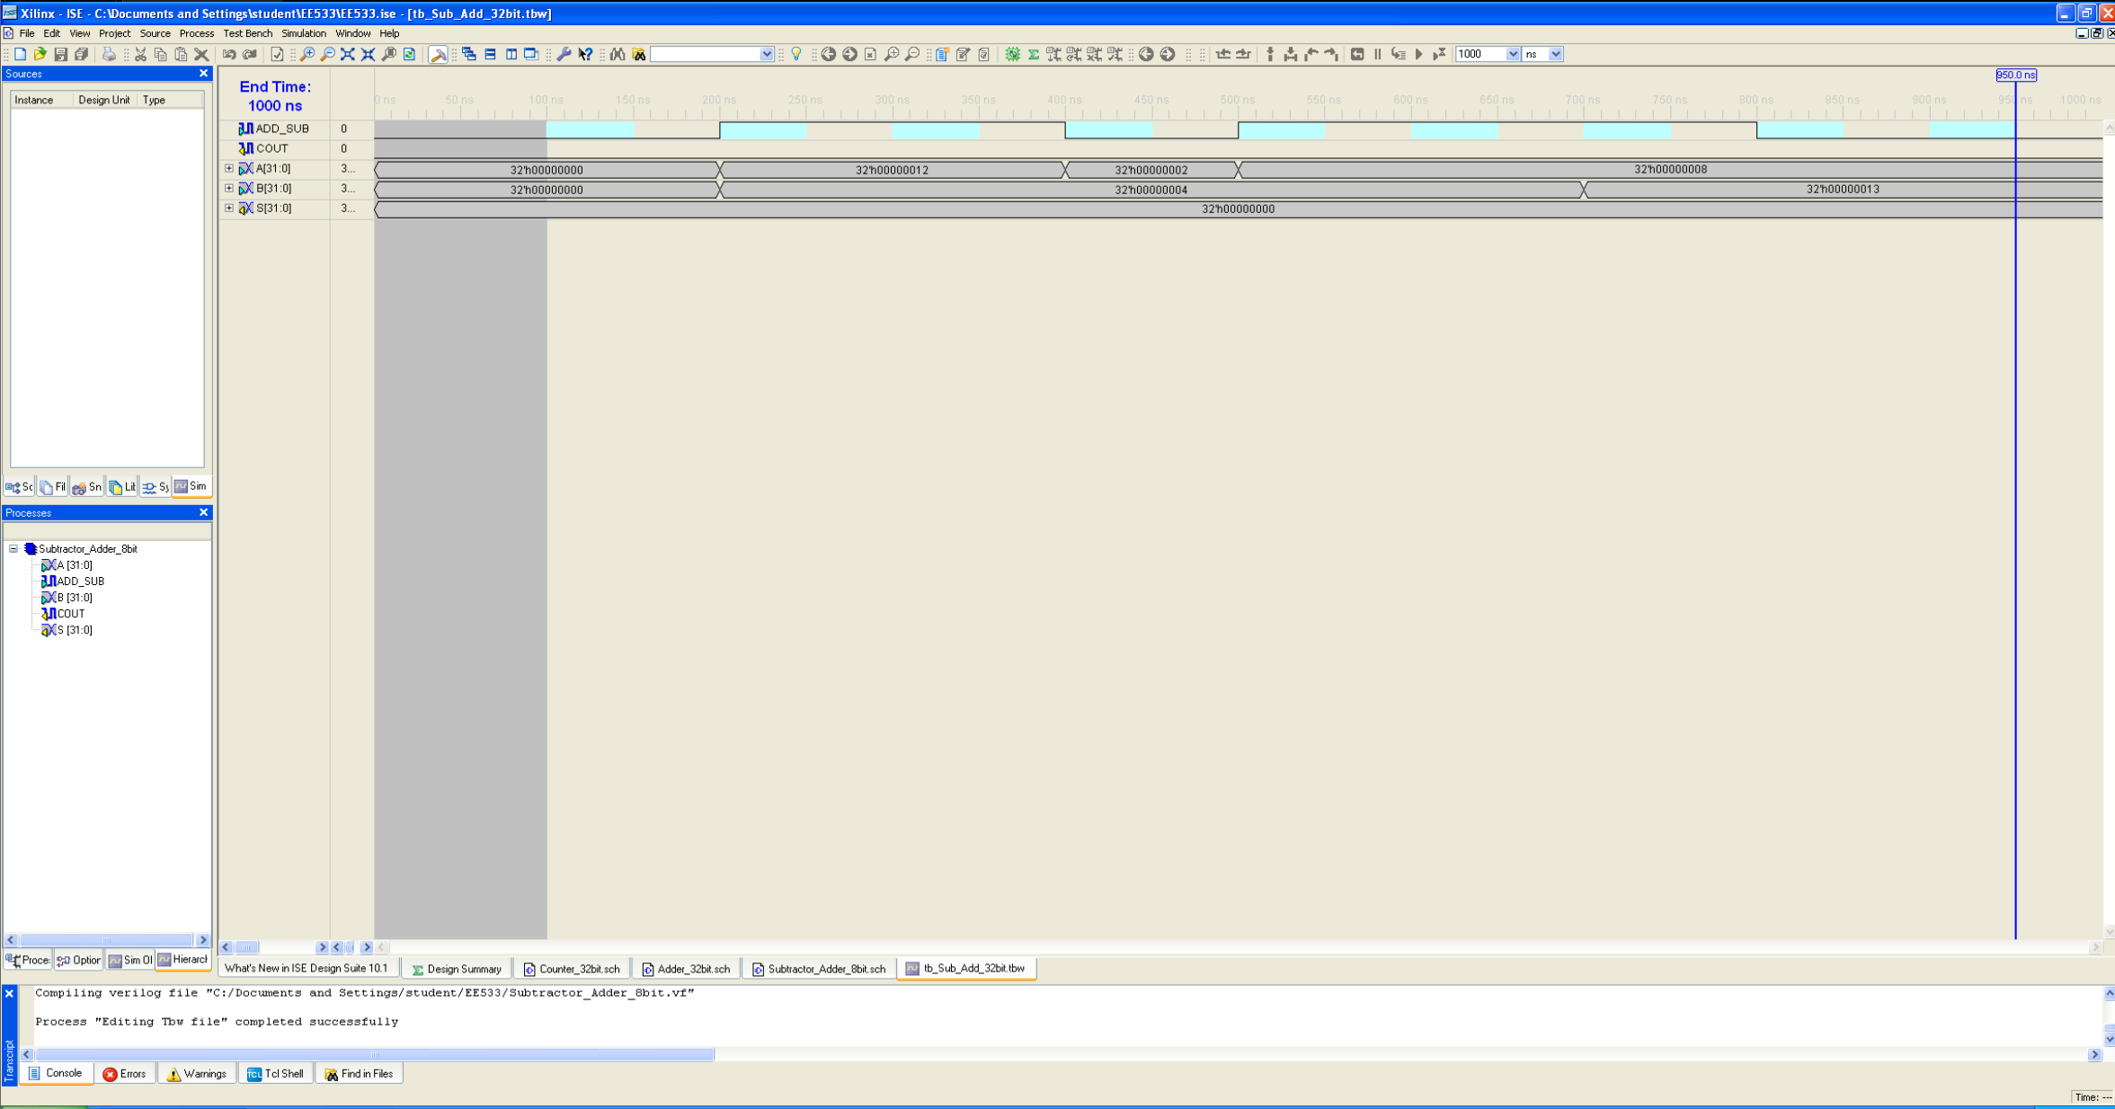

* + 1. Waveform/Simulation

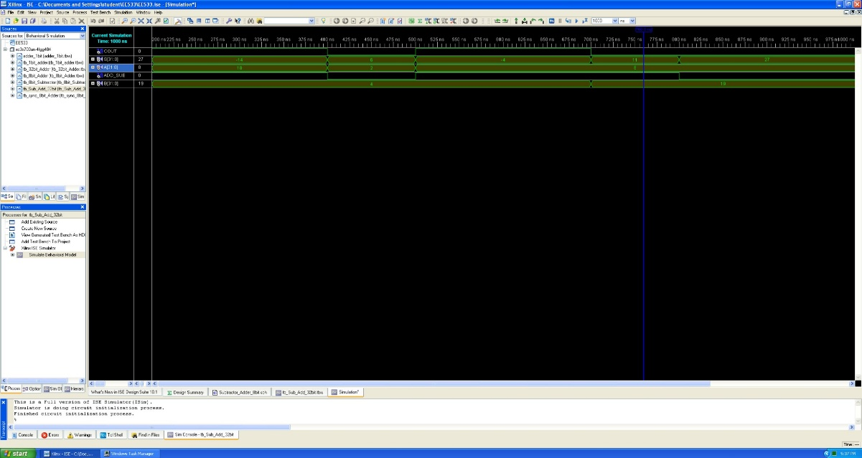

* 1. Left-Right 32-bit Shifter: This SHIFTER circuit performs both Left and Right shifting as shown in the schematic module below.
     1. Schematic

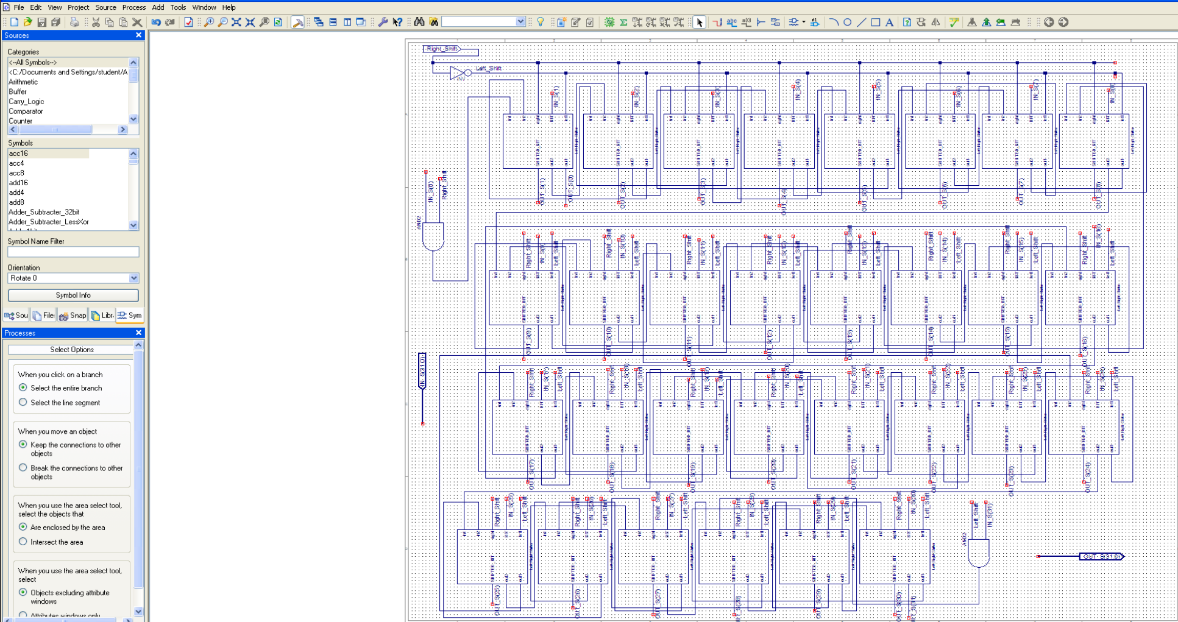

* + 1. Waveform/Simulation

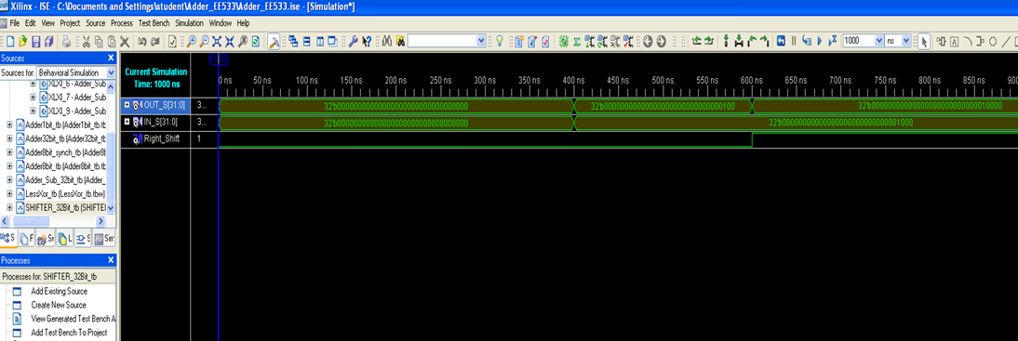

* 1. Multiplexer 32-bit symbol for 32-bit ALU: This multiplexer (MUX 32-bit (2-bit wide)) is used in the ALU circuit. The following symbol was used in the design.

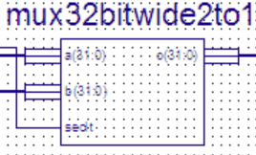

* 1. 32-bit Counter: This is the functionality of the 32-bit ALU, where I’ve incorporated a 32-bit COUNTER circuit.
     1. Schematic

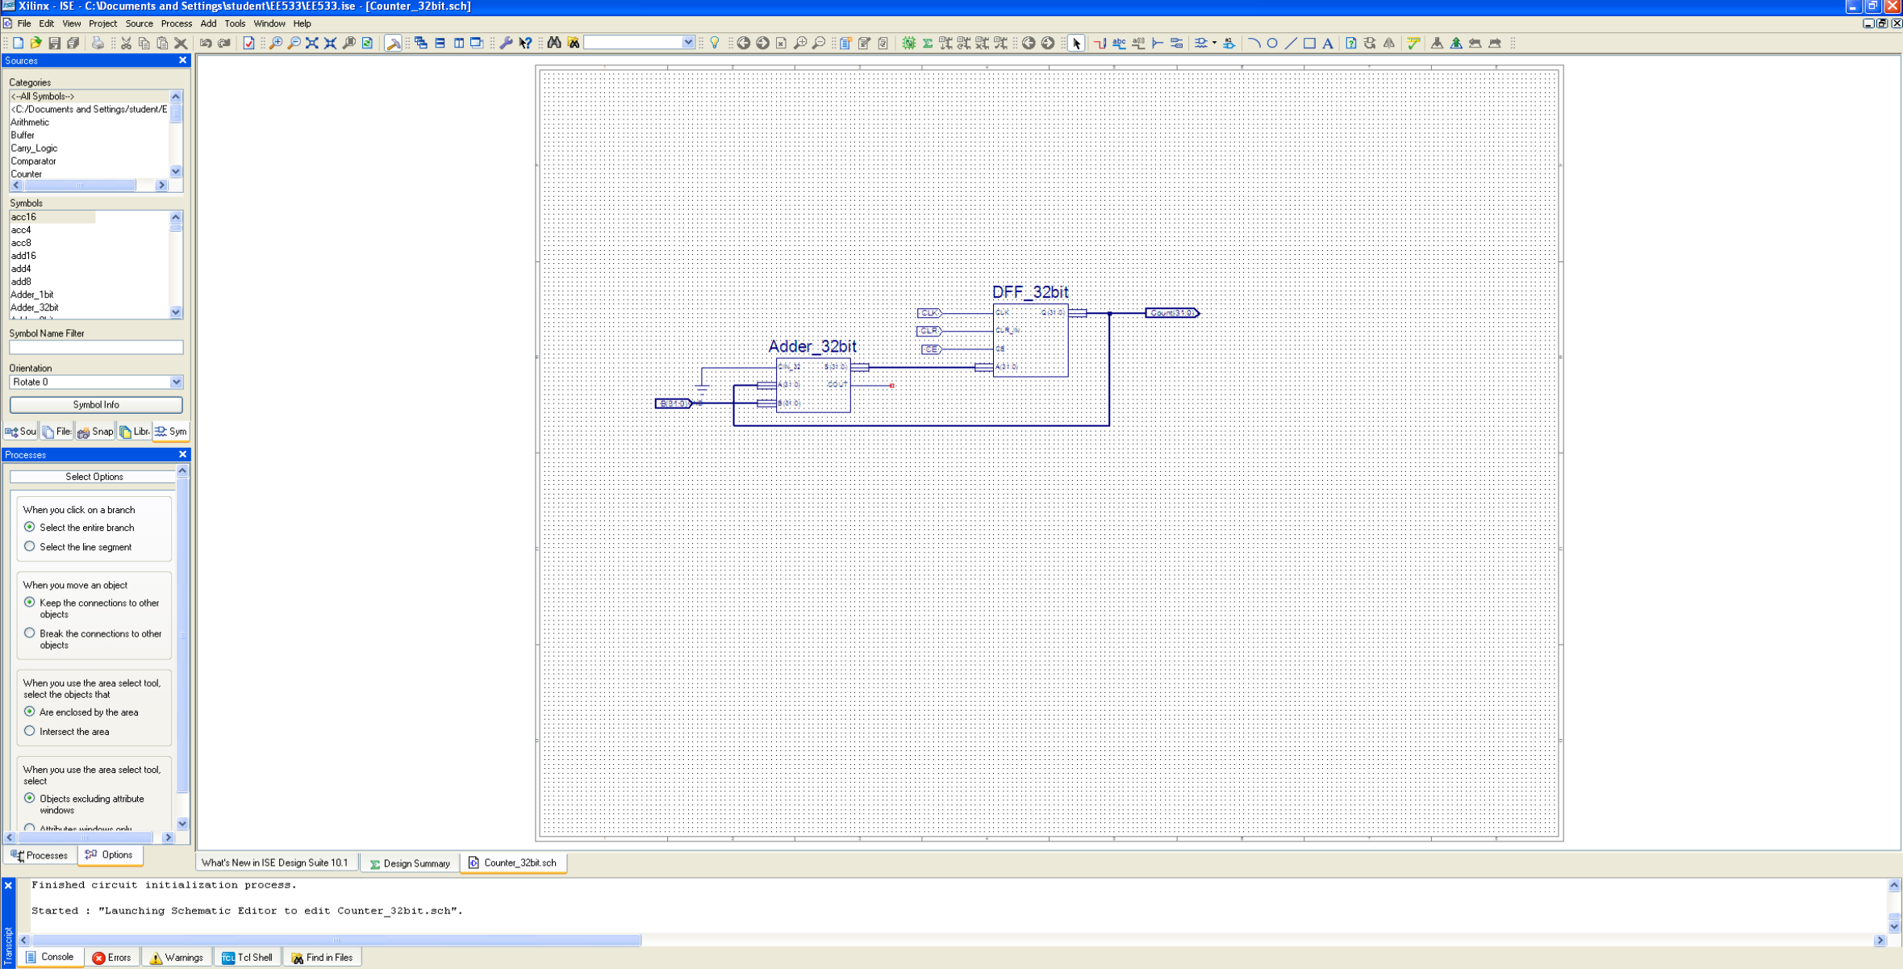

* + 1. Testbench

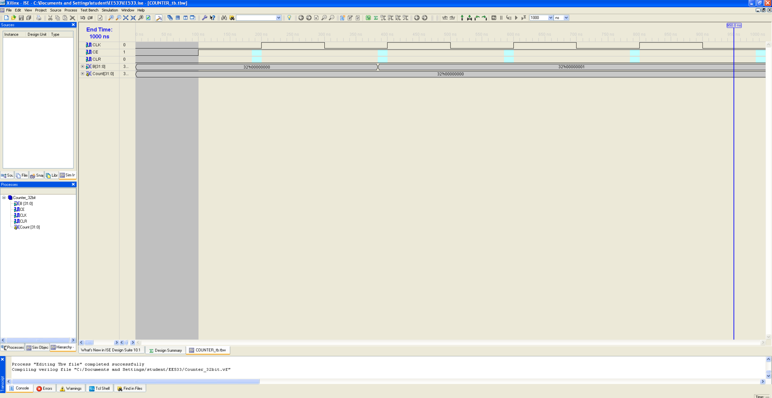

1. Verilog code equivalent for 32-bit ALU
   1. Screen capture of the waveform generated by behavioural simulation tools

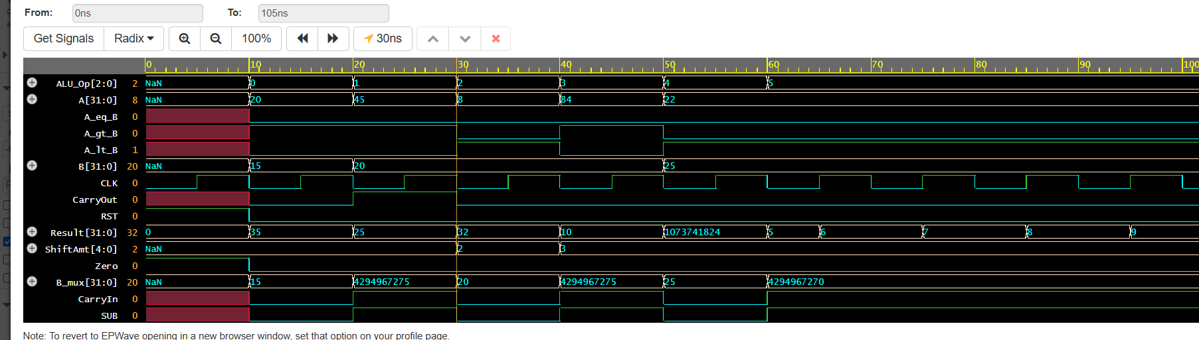

* 1. Log file of the mapper

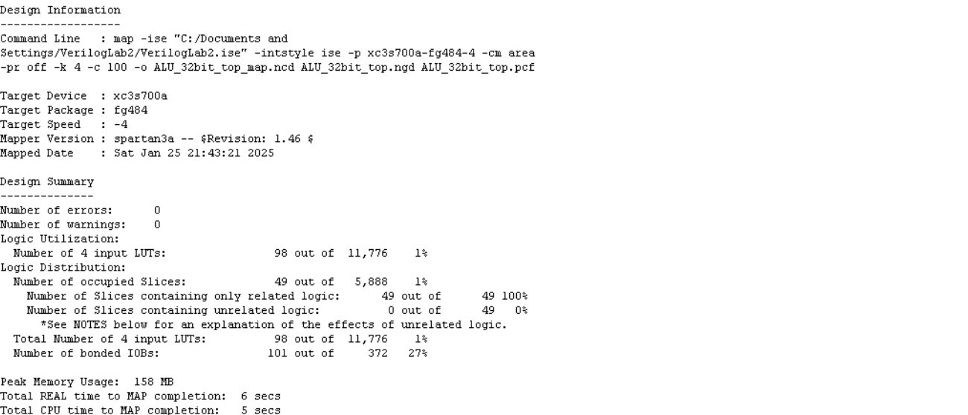

Design Implementation:  
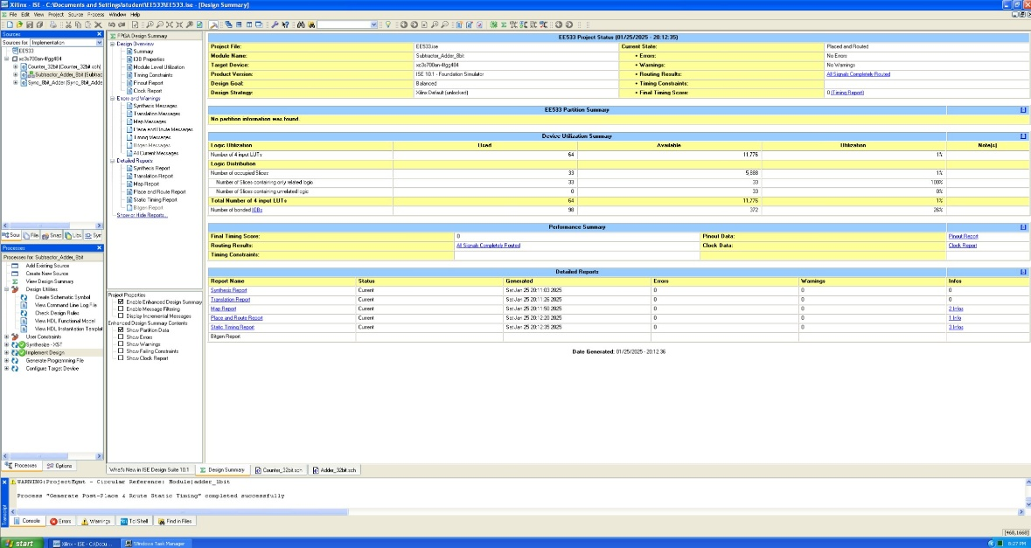

* 1. Brief comment on the number of gates as compared to the schematic version

*The number of gates compared to the actual design version is less than the schematic design implementation. This is because the schematic uses more GATES (due to DFFs & LUTs explicitly). Whereas the Verilog based design is synthesized into an optimized circuit, which includes less number of gates due to the synthesizer optimizer logic.*